SAVE BROWNHILL CREEK!
SS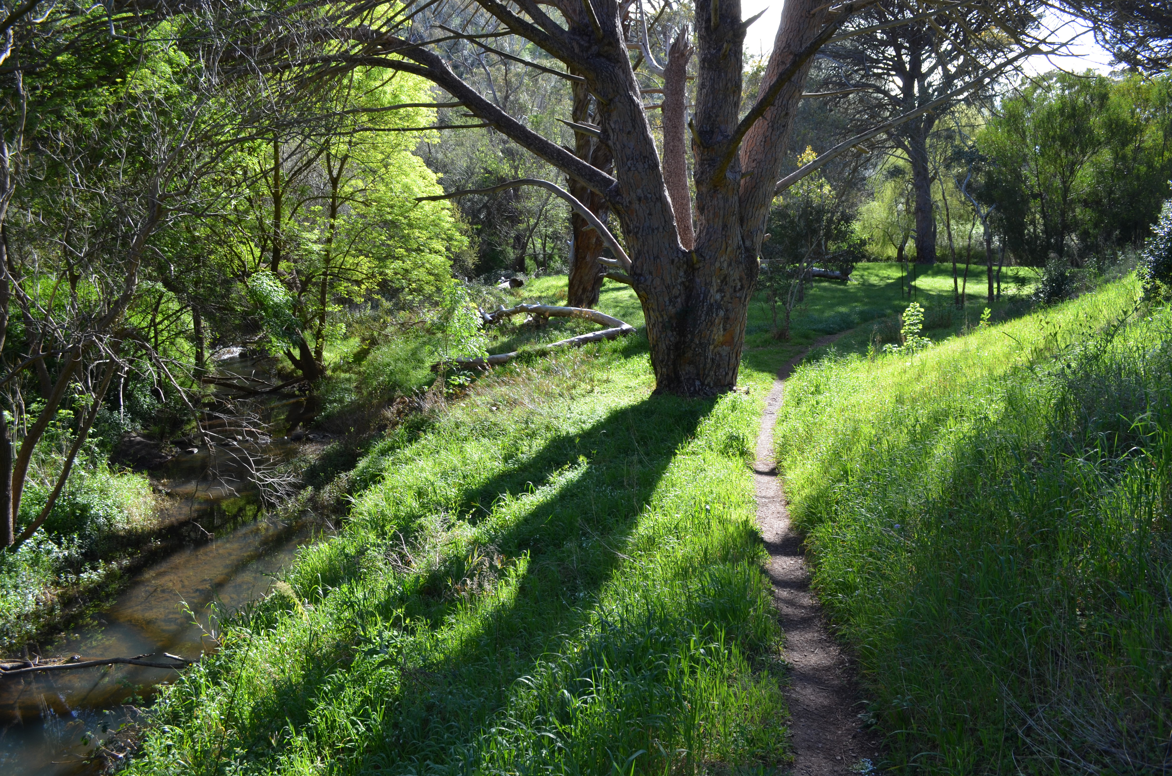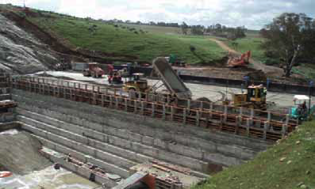
JOIN THE COMMUNITY CAMPAIGN
BECOME A MEMBER OF BROWNHILL CREEK ASSOCIATION Inc.

- “The purpose of the Association is to promote the conservation and enhancement of Brownhill Creek as a watercourse and scenic feature of the environment. This includes conservation and enhancement of the natural ecology and appropriate good management of land and activities within the catchment generally, as well as attention to human historic or heritage attributes of the creek and its catchment”.
- The No Dam in Brownhill Creek Community Action Group is a campaign sub-committee of Brownhill Creek Association Incorporated and the Association is aligned with The Friends of Brownhill Creek.
- After years of discussion and debate, 5 Councils (Adelaide, Burnside, Mitcham, Unley and West Torrens) are now finalising a stormwater management plan to address flooding issues. Part A works are agreed to (80% of the project) and Part B works are nearing agreement. It is time to have YOUR say and save Brownhill Creek Recreation Park & Ellison’s Gully: Kaurna Country/Wirraparinga.
- The project engineers have identified that the urban Brownhill Creek channel (Part B) has inadequate capacity to carry the required flows even with a dam! Creek Rehabilitation works and Creek Capacity Upgrade works have to be undertaken anyway.
- Some additional Creek Capacity Upgrade works (Option D) would mean that no dam is needed. This no dam option provides direct flood protection, is environmentally sound and costs less.
Don’t let a tiny minority succeed in derailing this breakthrough solution!
Join with us and work to ensure a better creek environment for future generations.

Name:__________________________________________________________________________________________________
Email:__________________________________________________________________________________________________
Telephone:_____________________________________________________________________________________________
Postal address:________________________________________________________________________________________
_______________________________________________________________________________________
Subscription: ☐ $10 Donation: ☐ $_______________________
Send with cheques etc. payable to Brownhill Creek Association, PO Box 113, Torrens Park SA 5062.
Bank transfer to People’s Choice Credit Union BSB: 805 050, Account Number: 2342677
www.brownhillcreek.org | brownhillcreek@gmail.com | Facebook: No Dam in Brownhill Creek

