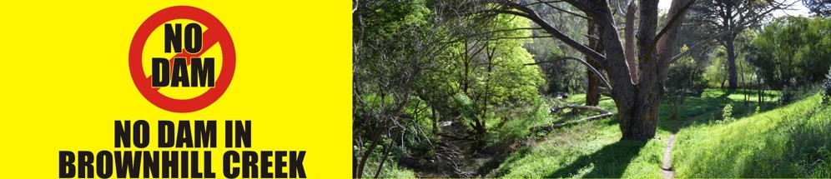

No Dam in Brownhill Creek Petition 2011-2013
Data Analysis
City of Mitcham | City of Unley | City of Burnside | Adelaide City Council | City of West Torrens | Other metropolitan suburbs | Country SA; interstate; overseas | Unspecified address | TOTAL signatories to Petition
3729 | 1109 | 323 | 209 | 162 | 2695 | 900 | 148 | 9275

Data compiled 09/12/13 by the No Dam in Brownhill Creek Community Action Group

