Flood Hydrology
What is the uncertainty of flood predictions?
Can revegetation be effective in reducing floodpeaks ?
Has the existing bank detention storage been evaluated?
What is the Flood Safe Program and how effective is it in reducing damage?

Flood Prediction
What is the uncertainty of flood predictions?
There is considerable uncertainty in estimated 1 in 100 year flood flow rates especially when the length of gauging station record is short. Increasing the length of flow record from 10 to 50 years will reduce uncertainty by about 50%. Other measures to improve flood estimates are
- improving the quality of flow record (checking that recorder works and weir is not blocked),
- performing gauging to gain better definition of the stage-discharge relationship, and
- taking account of changes in the catchment such as urbanisation and vegetation changes.

Wright and Kemp (2007) give a concise summary with examples including from Keswick Creek, where the 1984 flood mapping undertaken showed some parts of Cowandilla and North Plympton would have been submerged by a metre in a 1 in 100 flood. New houses were built on a layer of fill, and when in 2000, with more data, flood levels were revised downward it was realised that much fill and expense had been wasted. The cost of acquiring more data to make better estimates was trivial in comparison with the excessive costs incurred in building and infrastructure.
Stream | Gauging station | Length of record (Years) | Estimated Q100 m3/s | Lower Limit ,5%  (Years of Record) |  |  |  | Upper Limit ,95%  (Years of Record)
 |  |  |  | 10 | 20 | 50 | 100 | 10 | 20 | 50 | 100
Brownhill Ck. | Scotch College | 10 | 21.7 | 8.5 | 11.2 | 14.3 | 16.1 | 55.4 | 42.1 | 33.0 | 29.2
Wright, C. and Kemp, D. (2007) Flow estimation for flood management- understanding the uncertainty. 5th Flood Management Conference, Warnambool, 9-12 Oct 2007.
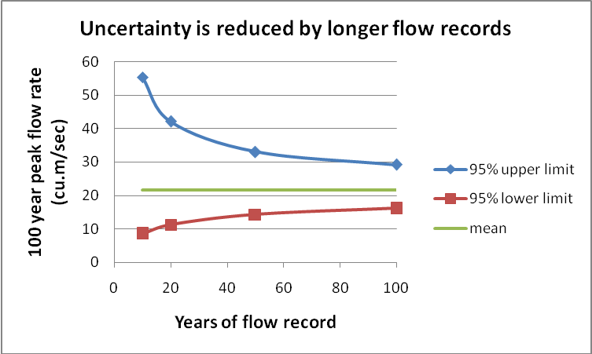
Impact of flow record on uncertainty of 1 in 100 year peak flow rate Brownhill Creek at Scotch College (from Wright and Kemp, 2007).
Hence one in 100 year flows are estimates only. They should not be viewed as anything more than indicative especially for streams with only short periods of reliable flow records like Brownhill Creek.
Vegetation and Flood Hydrology
Can revegetation be effective in reducing floodpeaks ?
Replanting riparian (river bank) vegetation has been shown to ‘roughen’ the flood channel, slowing the passage of water, locally increasing levels, and reducing downstream peak flows by delaying and dispersing the flood peak. Conclusive results are reported by Anderson (2006) for the Murrumbidgee River. An example of modelling results is shown below. Even when revegetation was applied to the river passing through Wagga Wagga, the decrease in peak flow due to upstream vegetation outweighed the small increase due to local vegetation.
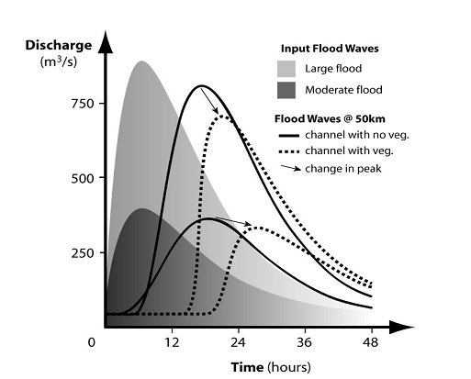
Numerical routing of two flood waves down a 50 km reach, with and without vegetation
(from Anderson 2006)

If a large part of an upland catchment is planted the effects on flows can be very significant. Some flood hydrologists dismiss these effects, but in long duration low intensity (<5mm/hr) 1 in 100 year storms the depleted subsoil moisture provides higher initial and continuing losses that reduce overland flow, increase bank storage, extend baseflow and reduce peak discharge. The effects will be most noticeable in permeable catchments with high baseflow, like Brownhill Creek (Clarke 2008), where the porous media beneath the ground surface acts like an underground detention dam releasing water gradually to the stream. Vegetation has already played its role before the storm comes, in creating greater unsaturated zone storage capacity. Vegetation also slows surface runoff helping disperse the peak while improving stormwater quality by reducing erosion. Friends of Brownhill Creek through their low-key riparian and terrestrial revegetation work, are already contributing to flood mitigation.

Bank Storage

Has the existing bank detention storage been evaluated?

Flow Duration Comparison
0.01
0.1
1
10
100
1000
0
10
20
30
40
50
60
70
80
90
100
% of Time Flow Greater than Value Shown
Flow ML/d
Keswick Ck at Richmond Oval
Brownhill Ck at Weigall Oval
Brownhill Creek has a very persistent baseflow, more than 75% of time having a flow rate greater than 1 ML/d (12L/s)compared with Keswick Creek with less than 25% time (from Clarke 2008).

The fractured-rock and alluvial aquifer system of Brownhill creek has not been evaluated for its impact on flood hydrographs for long duration low intensity events, which are the only storm type that the consultants are claiming a surface dam would affect. Surface detention would be redundant if there is existing unaccounted-for subsurface detention. A crude estimate of alluvial flood detention storage capacity in the Recreation Park valley floor is 60 ML **with tributaries upstream contributing possibly a similar amount. The flow duration curve from Clarke 2008 suggests that the magnitude of low flow bank storage (in the range 1-10ML/d) is of the order of 800ML# for Brownhill Creek (about 10 times that of Keswick Creek). Not all of this is activated during a storm. However during a storm when creek levels rise, some water soaks back into the banks and when levels drop this discharges back into the creek. This natural form of detention storage is given greater opportunity to have a mitigating effect on longer duration storms in Brownhill Creek, the only type of design storms for which a proposed detention dam could have any influence.

Flow hydrographic records have been derived from Scotch College Gauging Station since 1980, so in theory bank storage upstream of this point has already been accounted for in deriving 100 year recurrence interval flood records. However the cobble-studded river channel for at least 6 km downstream is likely to contribute to bank storage that has not been accounted for in modelling to date.

Anderson, B. G. (2006). Will replanting vegetation along riverbanks make floods worse? River Symposium, Brisbane, 2006.
Anderson, B.G. (2005). On the impact of riparian vegetation on catchment scale flooding characteristics. PhD Thesis, University of Melbourne.
Clarke, R. (2008). Stormwater harvesting within the Patawalonga catchment. Report to SKM. September 2008. Richard Clarke and Associates.

**2m thick * 50m wide * 0.1 (effective porosity) = 10 KL/m of stream bed length = 10 ML/km A 6km length of stream bed in the Recreation Park would store 60 ML and for tributaries upstream, dimensions are smaller but lengths may be longer.
# 270 days between 10 and 1 ML with a mean of 3ML/d suggests up to 800ML of storage. More exact calculations could be made using actual flow records.

