BROWNHILL CREEK ASSOCIATION INCORPORATED
Re Brownhill Keswick Creek Draft Stormwater Management Plan

1. Systemically Poor Development Planning
The need to prepare a Stormwater Management Plan in the region is the result of short-sighted and opportunistic building development in flood prone areas throughout the catchments in question. This poor planning practice continues to the present day, and without this issue being properly addressed, the proposals in the draft will not only fail to address flooding of some 1321 properties, but many more additional future developments.

By way of illustration, attention is drawn to the fact that in 1862, when “Bella Vista” in 13 Wooldridge Ave Millswood was constructed as a then farmhouse, there was a raised plinth and floor levels were approximately 75cm above ground level (see illustration below).

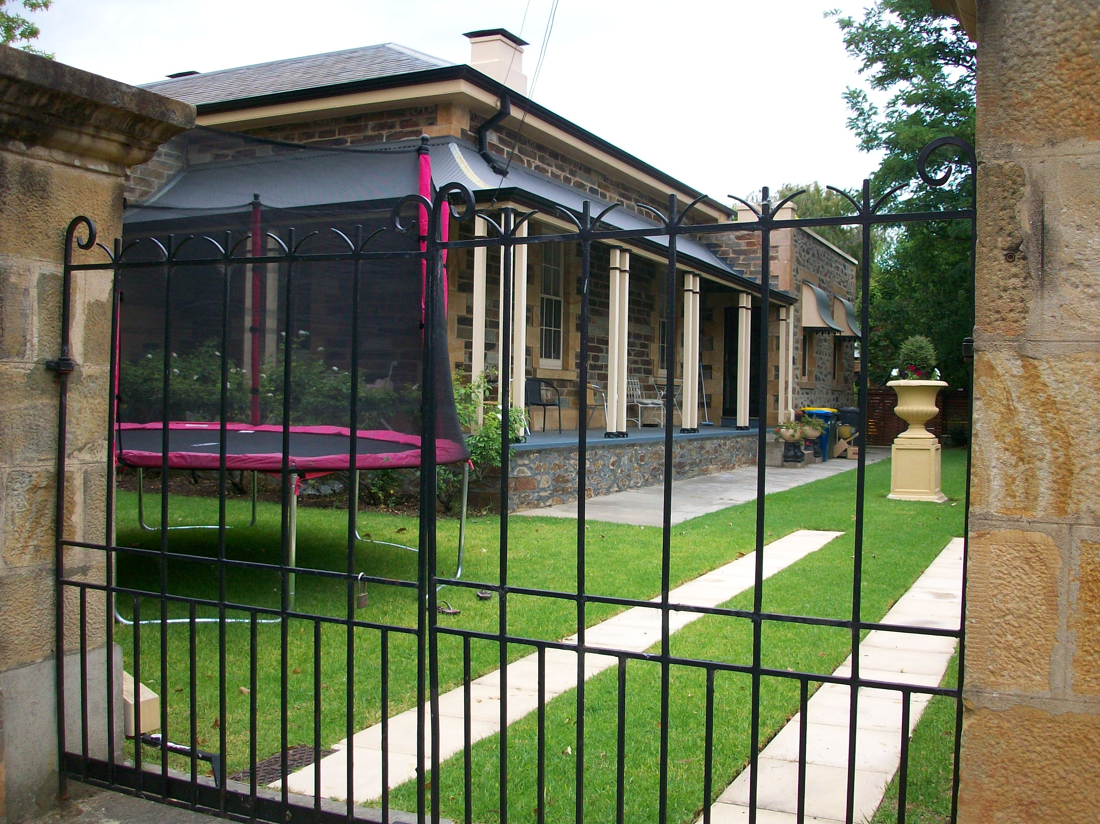 13 Wooldridge Ave Millswood, showing raised plinth

This property is in a flood prone area, but its builders understood and constructed it accordingly. From the 1880s when building development boomed around Australia (leading to the first great depression of the 1890s), few speculators and builders continued with such precautions, a pattern echoed to the present day.

Recent housing development in between Charles Walk and Charles St, Unley immediately adjacent to a watercourse makes little attempt at flood mitigation for example, with some 50 townhouses constructed at ground level adjacent to a (now covered over) part of the Glen Osmond/Keswick Creek System (see illustrations below). This pattern is repeated in Windsor St Parkside, while in Lyons Parade Goodwood some 30 townhouses are constructed over the top of Brownhill Creek. New individual houses with below ground garages have been constructed in locations adjacent to the creek, as in Malcolm St Millswood.

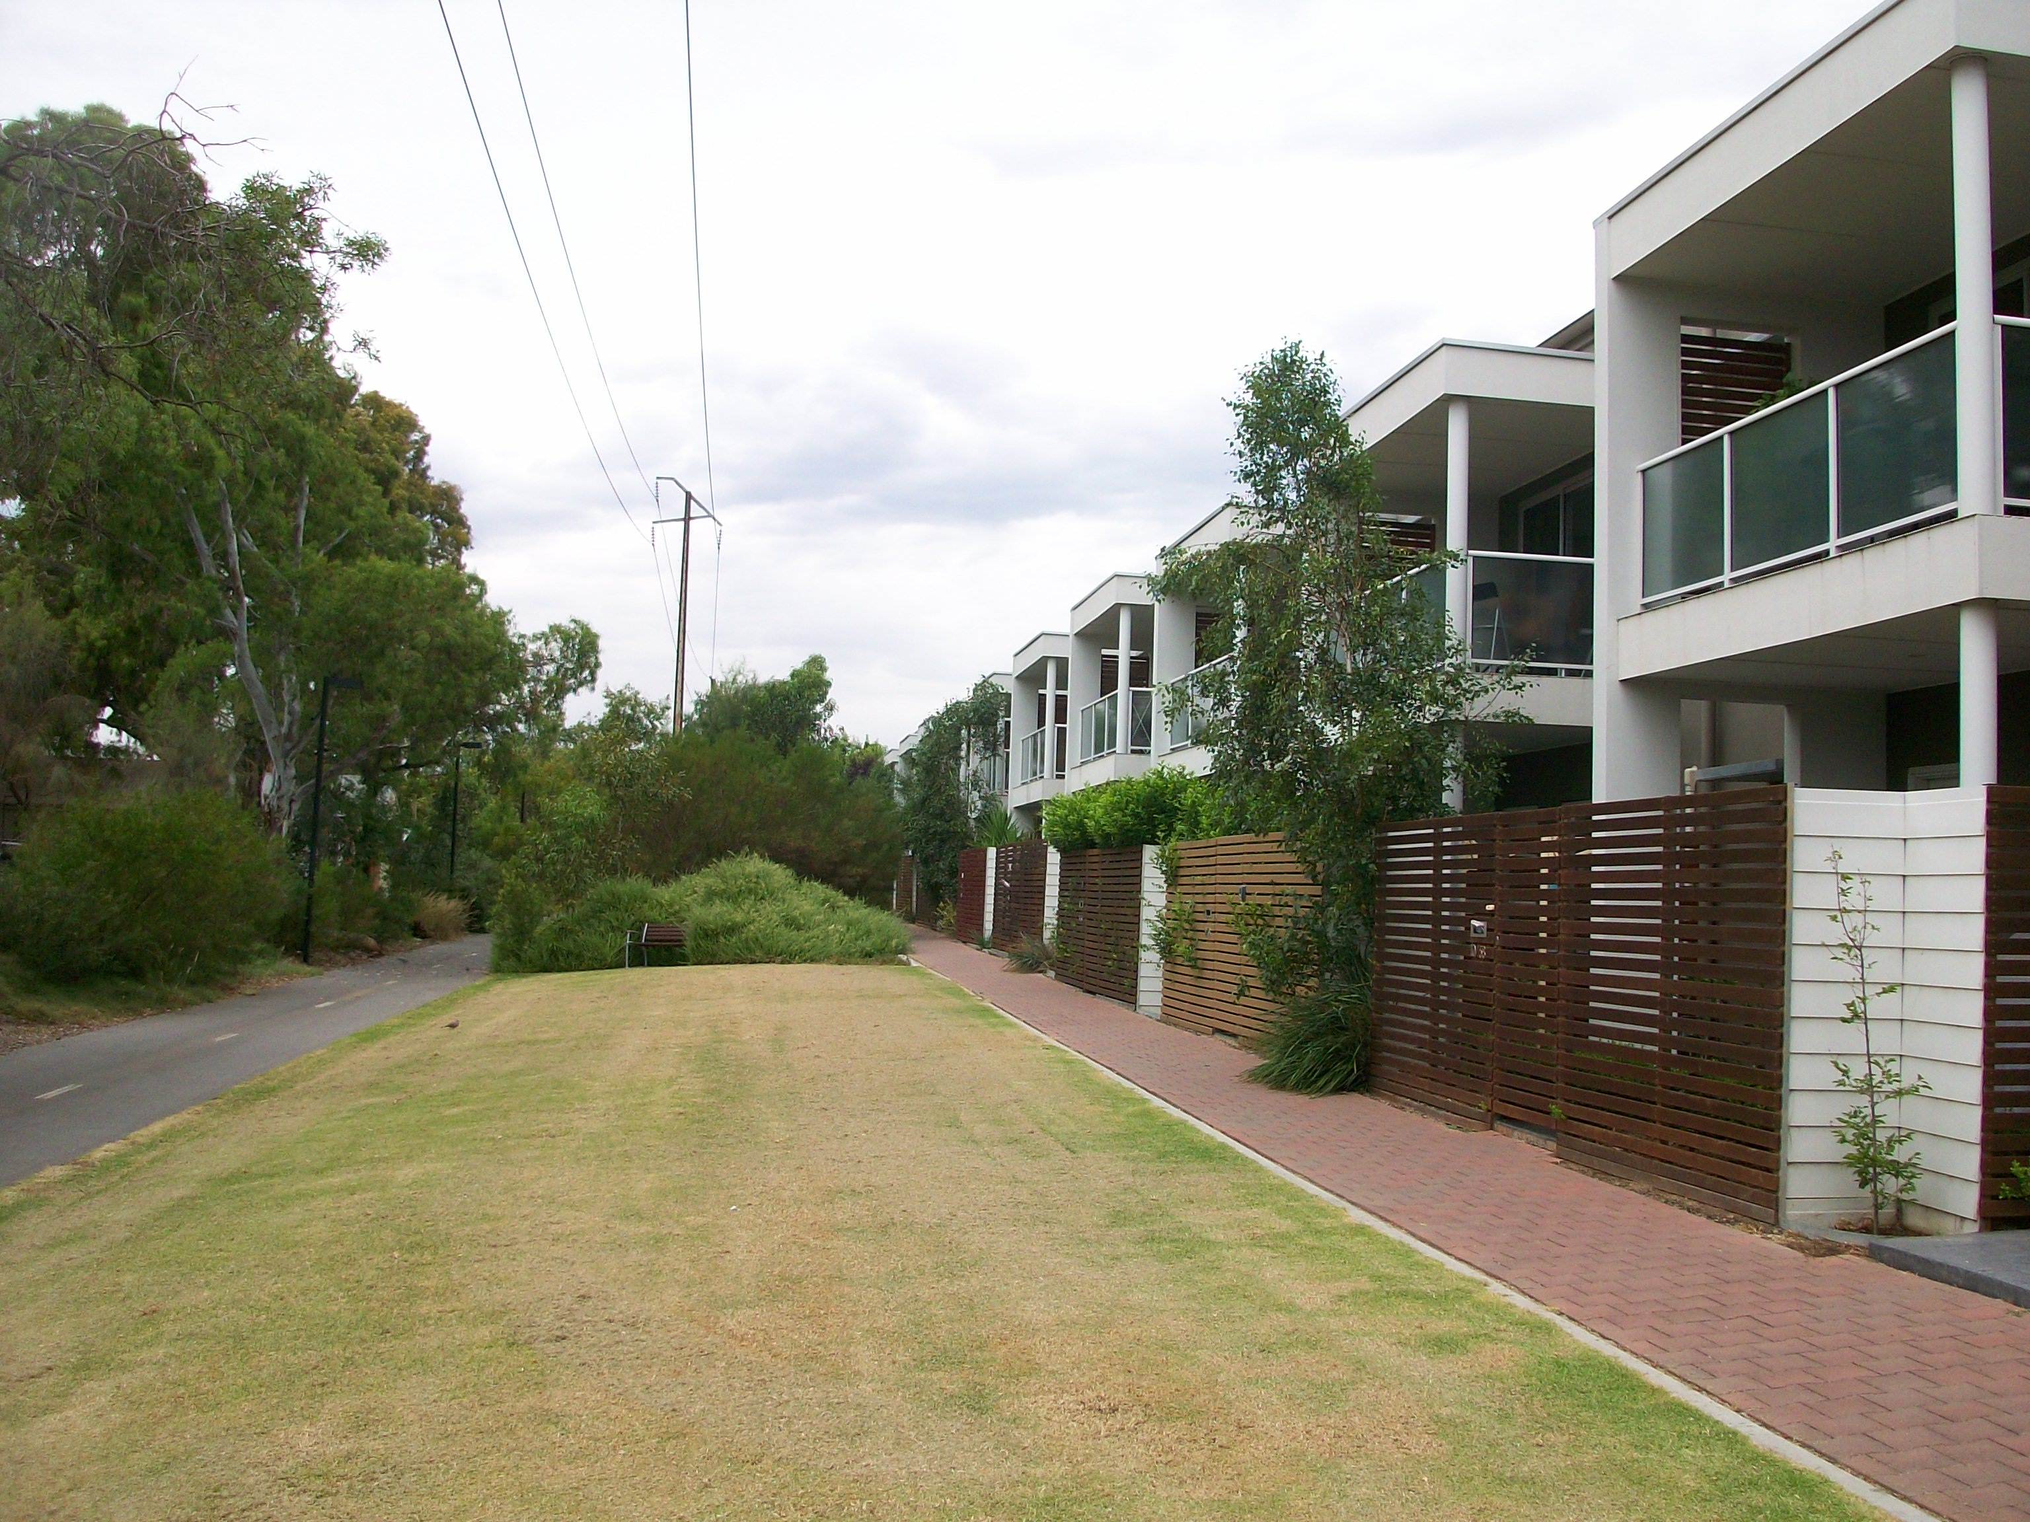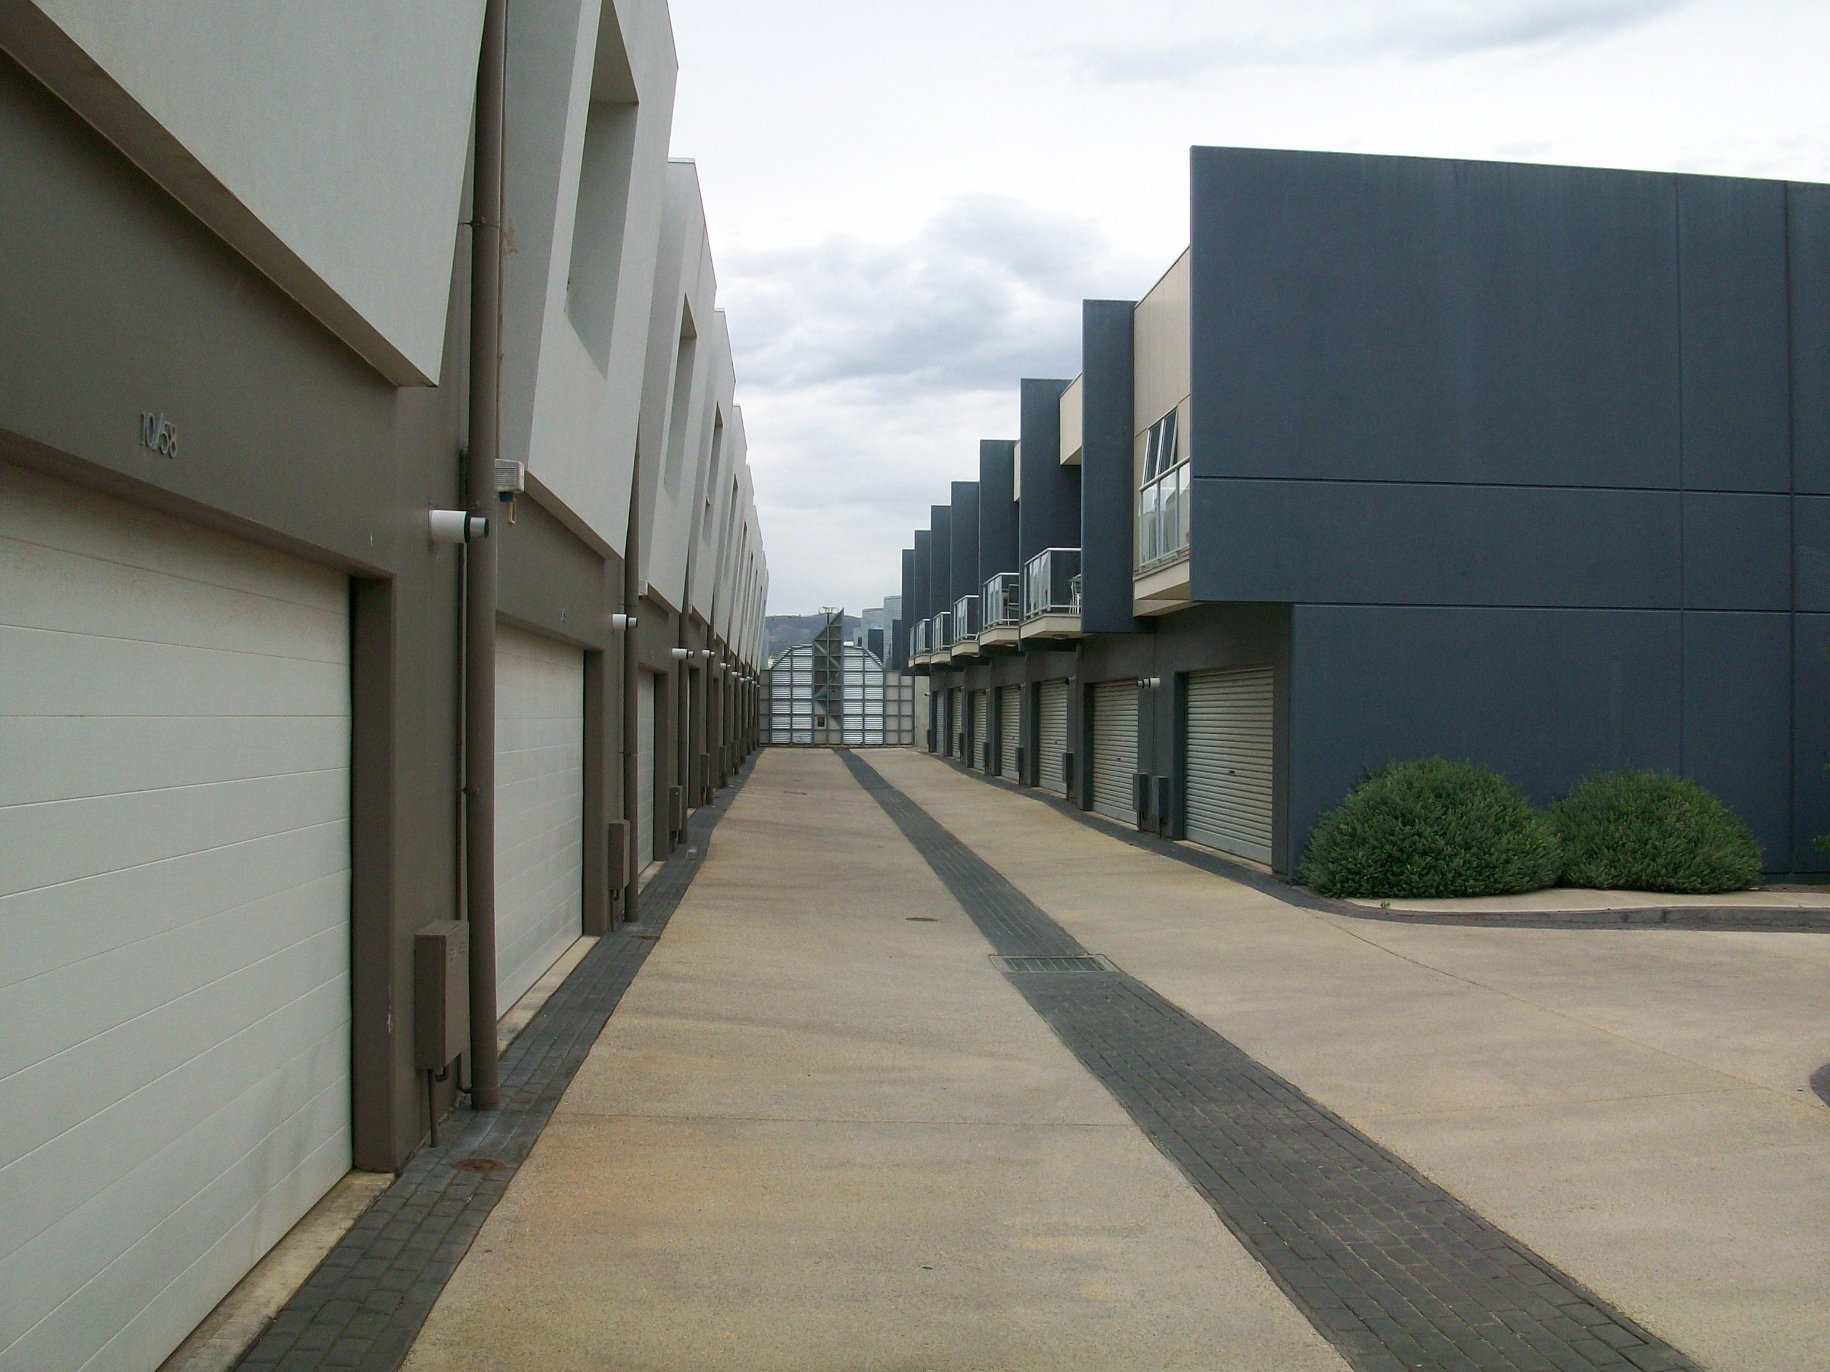

Charles Walk, Unley, covered watercourse at left Ground level housing adjacent Charles St Unley

This pattern is repeated throughout the catchments, with extensive new housing in the proximity of the Keswick Creek channel in streets to the North of Richmond Oval, for example. The new library behind West Torrens Council chamber even appears to acknowledge its floodplain site with a very low bund to the north. In Mitcham the shopping centre owners have recently been allowed to construct a two level underground car park immediately next to Brownhill Creek, although it is known cars are generally written off when subjected to flooding. A new house in Paisley St Torrens Park is constructed partly across the creek.

All such recent development may be deemed acceptable if it is understood that periodic flooding is an ongoing risk in such situations, and the same applies to the much larger areas of building development erected on flood prone sites since the late 19th century (6921 properties according to the Draft Plan).

However, in the light of long held knowledge of flood risks, it is quite inappropriate to base a Draft Stormwater Management Plan on a premise that a majority of such properties should be protected from periodic flooding, as appears to be the case.

Steps before construction of any flood mitigation measures should include:

1. More stringent and effective Development Plan amendments relating to future building on flood prone areas. There should be amendment of the Development Act 1993 and state-wide Development Plan provisions and building rules under it to require Water Sensitive Urban Design so that industrial, commercial and domestic developments have at least:
- Water permeable paving wherever possible including paths, roadways and open spaces.
- Significant rainwater collection (underground if necessary) on all properties in quantities directly related to roofing/impermeable surface areas (and filtration for re-use where appropriate).
- Soakage pits to receive excess runoff from roofing and hard paved areas.
- Floor levels that are above 1 in 100 year flood levels in flood prone areas.
- All structures (such as small sheds, railings etc) in flood prone areas to be secured from possible removal in a flood event.
- Mandatory provisions to protect against flooding on flood prone sites (such as bunds, retaining walls) and maintain clear watercourses (e.g prohibition of housing/structures over watercourses) to be applied by local and state development assessment panels and commissions in considering all development applications.

A key provision under this Development Plan amendment should be that all development on flood prone sites is referred to the Stormwater Management Authority, which should have powers to direct rejection of inappropriate development applications, or direct changes to development applications to include flood mitigation.

The Development Plan (and indeed other legislative provisions) should be further amended to actively encourage individual housing and development of housing areas that adopt the self-sufficient approaches to rainwater and grey water collection, retention, use, treatment and re-use in line with those pioneered by Michael Mobbs for his terrace house in Sydney NSW.

2. There should be requirement (under amendments to the Local Government (Stormwater Management) Act 2007 (or new legislation if necessary) that any Flood Mitigation and Stormwater Re-use Plan for a catchment includes:
- Required flow capacities in all watercourses, with clear guidelines for interpretation and enforcement by local Councils and any other bodies managing them.
- Plans for initial clearing of watercourses of exotic trees and obstructions supported by government funding, including property acquisition if necessary for that purpose. Thereafter, watercourse maintenance could be by landholders, enforced by local Councils, except that removal of sedimentation and other material washed down from upstream could be eligible for grant assistance.
- Proposals for revegetation of cleared rural hinterland with native trees, shrubs herbs & grasses (to reduce flood runoff by 14% or more).
- Requirement to install rainwater collection facilities for all existing development in urban areas, with a new grant scheme offering larger amounts for larger capacity tanks, and assistance with plumbing rainwater into domestic/garden use in a way that ensures rainwater is used before any mains water (in turn ensuring tanks are partly empty to collect water in extreme rainfall events).
- Requirement that future reconstruction of all municipal footpaths be water permeable, with road guttering/kerbing containing permeable sections adjacent to street trees.
- Proposals that wide local streets be reconstructed to include water permeable median strips/traffic calming.
- Creation of small detention basins/wetlands and floodwater diversion basins, with aquifer recharge in open spaces along watercourses (in both urban and rural areas).
- Broadening of creeks and creation of meanders (rather than outmoded high flow-speed concrete channelling) with wider bridgeworks where appropriate. Creek broadening could occur in many creek-side reserves, while meanders and flood-meadows could be created in larger Parks and rural catchments.
- Liaison/collaboration with the Natural Resource Management Board for the region.
- Set overall targets of at least 20GL per year of rainwater harvesting and at least 106GL per year of stormwater collection and re-use and 50GL per year of waste/grey water re-use.

3. Under the above legislative provisions there should be establishment of a Floodwaters Mitigation Program parallel to Bushfire Prevention Programs (but wider and better funded than the voluntary “Floodsafe” program), with:
- Detailed risk assessment of flood damage potential to individual properties (to promote awareness and preparedness).
- Encouragement of individual property holders to prepare Flood Plans.
- Grant assistance with building levees or retaining walls, sandbags and other measures.
- New guidelines to reduce potential obstacles (structures and loose objects) in flood prone areas.
- Annual inspections of watercourses.
- Regionally based officers to implement the program.

4. There should be establishment of a government-assisted Mutual flood damage insurance fund to help cover property holders in flood prone areas. Insurance would be available to property holders adopting appropriate floodplain management standards and/or plans. This could cover catchments of all the greater metropolitan Adelaide creeks and rivers to give necessary scale, and would be potentially even more viable if adopted at a federal level.

In the USA there has been a National Flood Insurance Program under the National Flood Insurance Act 1968, which also provides for purchase with federal funds of flood-prone land for more appropriate uses such as open space. The Unified National Program for Floodplain Management aims to reduce flood hazards and their impacts through land use management by regulation, zoning, construction codes and utilization of natural values of floodplains.

2. Poor benefit/cost analysis
The benefit:cost ratio is in the region of 0.65 which means the costs of the project are 50% more than the benefits, a poor basis for proceeding to begin with. The benefit:cost ratio makes no attempt to quantify the cost to the environment or the huge amount of voluntary work done over 10 years or more in rehabilitating the proposed dam site in Brownhill Creek Recreation Park, even though hours worked and the commercial value of such time are accessible, and there are known formulas for valuing trees economically. An active Friends of Brownhill Creek has been involved in volunteer park management since 1985 contributing some 630 hours per year. Other community groups voluntarily working regularly in the park include the Lions Club, Rotary Club (both Hyde Park and Brownhill Creek branches), The Body Shop staff, Mercedes College students, Scotch College students, Landcare and Correctional Services volunteers.

Nor is there any attempt to estimate the cost of alienating such volunteer workers from their crucial role in park maintenance, nor the trauma and other social impacts of destruction of the park amenity. It is not clear if the economic impacts on the caravan park business (likely to be very substantial with 20-30 ton trucks rumbling past during the construction phase of some years) or residential property values in the locality have been considered. It is suggested that at least these factors would mean an even poorer ratio.

Nor is the impact of property insurance clear in the discussion of benefit:cost. Given the infrequency of the event planned for, insurance may be a perfectly appropriate option to many of the effected properties.

To base such massive expenditure ($133Million) on a poor benefit:cost basis seems inappropriate in view of the known history of flooding at most of the sites in question and the calculated risk taken.

3. Speculative estimations of flooding
Although it is understood the flooding estimate from a 100 year ARI storm is based on the best available data, it is noted that this is purely a statistical estimate based on a relatively short period of available data, and that such a 100 year ARI flood has not been recorded in the 175 year history since European settlement of SA.

Neither is it at all clear what the effect of global warming through greenhouse gases or other causes may be on rainfall and flooding.
The map provided in the publicly circulated documents fails to reveal that the vast majority of estimated flooding is of less than 100mm. The impression thereby created is arguably misleading and fear-mongering, when a simple photocopy (let alone the quality printing undertaken for the publicly circulated documents) of the more informative map in the full Draft Plan could have revealed a much more accurate picture. Similarly the figure of properties subject to flooding (“7000”) does not differentiate between above and below floor level flooding. While it is accepted there may still be damage from the latter, it will be significantly different.

Even if the above failures are deemed acceptable, there has been no attempt to illustrate the flooding risks in any way that is meaningful to many in the community. How would 100ml or less in the majority of the area illustrated in the map affect households, or compare with a sudden and very heavy downpour that might be experienced every year? Would the gutters in the street fill up for 10 minutes (as might happen every year) or all day? For some of the areas more seriously flooded, would sandbagging, bunds or pumps be partly or wholly effective?

Given the high number of properties still to be subject to flooding if the plan is implemented (1321 out of 6921, or close to 20%) the rather speculative statistical estimates involved and the poor project benefit:cost ratio; much more detailed information on flooding must be supplied to justify the project.

4. No dam option
The report commissioned from Worley Parsons Preliminary Assessment: Enhancement of Flood Mitigation Options dated 16 November 2011 identifies a no dam option for the project.

Since a major objection to the previous proposal in 2007 by Hydro Tasmania for two dams was strongly opposed by the community because of its detrimental impacts on the heritage and environment of Brownhill Creek Recreation Park and environs, why were no dam options not always an integral part of the Draft Stormwater Management Plan released for public consultation?

Why did the additional 16 November report not form any part of the Open Days and public consultation, when it was known to be coming and was in fact released before the first open day? A simple supplementary summary sheet could easily have been produced and photocopied in time, and full copies made available for perusal on the days. As it was, the public were given incomplete information upon which to base their comment, and the consultation is fundamentally flawed.

It would seem then the public consultation process has been ill conceived and premature, since the documents and other material prepared for it failed to adequately address a fundamental community objection raised 3-4 years previously.

5. Other alternative options
The Draft Plan fails to adequately investigate the option of revegetation of the cleared rural parts of the catchment. Much of the Brownhill Creek catchment has been cleared since colonial times and now contains mono-species infestations of pest plants such as artichoke thistle, feral olive or Aleppo pine.

Research has shown that revegetation of cleared catchments with a suite of indigenous species can reduce surface water runoff by 14%. With the other proposals in the Plan such as channel widening and diversions, such reduction of runoff could obviate the need for a dam in Brownhill Creek Recreation Park.

The only response to this when raised has been that such an approach might not work when the catchment is already saturated. By the same token, the proposed dam might not work if the projected heavy rainfall events fall on the Adelaide Plains below the dam. The latter seems quite likely in view of historical records.

The Draft Plan also fails to investigate the option of stormwater retention and re-use through underground tanks. The City of Tokyo has a 9 million cubic feet concrete flood water control tank under a playing field, with water reused for watering the grass. There are at least 6 ovals in the Brownhill Keswick Creeks catchment, including several close to the watercourses. Such tank storage would meet the clear statutory objectives of sustainability and reuse of water under the Local Government (Stormwater Management ) Act 2007 .

The Draft Plan focuses on so narrow a range of options as to be manifestly inadequate (with this clearly revealed by the report subsequently commissioned from Worley Parsons by Mitcham Council and published 16/11/11).

6. Heritage impacts
The proposed dam in Brownhill Creek Recreation Park fails to adequately consider the high heritage value of the Park.

The Park was reserved for public purposes by Governor Grey in 1841, making it one of the oldest reserves in Australia (predating the oldest National Parks in the world at Yellowstone USA (1872), Royal National Park Sydney (1879) and Belair (1891)).

Declared a “National Pleasure Resort” in 1915 under then new SA legislation, it was later made a Recreation Park under National Parks & Wildlife Act 1972.

It is designated as a Category III Natural Monument by the IUCN-World Conservation Union, and has the international objectives of protection and preservation of natural features and prevention of exploitation or occupation inimical to such purposes. A flood mitigation dam would not protect or preserve natural features – indeed it would fundamentally interfere with and compromise natural processes in the park which include periodic flood-water flows. These are recognised as beneficial to the environment.

The Park includes at least 99 native plant species (27 of “conservation significance”), including Grey Box grassy woodland, (Eucalyptus microcarpa) in the western side of the Park listed as endangered under the Environment Protection & Biodiversity Conservation Act 1999 (Cw).

The Park provides habitat for 7 native mammal species (including kangaroos, koalas, echidnas and the endangered Southern Brown Bandicoot); at least 37 native bird species including the vulnerable Yellow-tailed Black Cockatoo; 7 reptile species and 3 native fish species including threatened Climbing Galaxias and Mountain Galaxias which are unique to the Adelaide region.

The 53ha Park is a long (approx 3.5 km), narrow finger of reserved land in a steep valley and the proposed dam will be in the middle, creating a wall across the valley and effectively bisecting the park in a way discouraging use of the other half and changing the park configuration forever.

The Park is visited by some 40,000 people each year, including interstate tourists in the Caravan Park.

The proposed dam site is a popular picnic dell adjacent to the creek and includes “The Seven Sisters”, Stone pines planted to mark federation.

Other heritage features of the park overall include a suite of rusticated stone buildings of the 1950s, an important reflection of new tourism approaches of the period. This includes a caretaker’s cottage, kitchen, toilets/showers, laundry block and kiosk in the same style.

At the entrance to the park is a fine stone monument, erected in the 1950s by the Tourist Bureau which took over management of the Park for a period up until 1972, and it is thought to be the only such remaining monument.

The remains of a municipal swimming baths in the creek nearby date from 1893.

There is a handsome entrance avenue of oriental plane trees, planted at a ceremony in 1907 led by first Labor Premier Tom Price (1852-1909), and named in his honour.

The valley floor in the first part of the park on either side of the River Red Gum “Monarch of the Glen” (estimated to be over 500 years old) was not only the site of early Aboriginal and colonial occupation, but also a venue for a range of recreational activities. An early painting by WA Cawthorne refers to rifle club activities in 1868, and the “Monarch of the Glen” has been painted by a number of artists including John Goodchild (1898-1980). The “Monarch of the Glen” is listed on the National Trust of SA Register of Significant Trees.

Running through the park are iron pipes with ornamented joints cast in Glasgow, which form part of the historic Mitcham Waterworks (1879), one of very few remaining colonial regional water supply systems. A particular feature in the Park is the cast iron drinking fountain with dog dish at the bottom, adjacent to a large oak near the southern end of the present camping ground. This waterworks (of which the tanks on Carrick Hill Drive are State heritage registered) are described in detail elsewhere.

The creek crossing at White’s Bridge (with its early bluestone plinth) is believed to have been named after a local farmer J White who was the subject of the first SA labour strike for higher wages in 1843. The reinforced concrete span added later was one of the earliest in Australia.

Just past the bridge to the right is the former colonial government quarry, supplying kerbstone for Rundle and Hindley Streets and stone for early buildings (e.g. Kent Town Brewery). Rogers freestone quarry located here also supplied stone for city buildings such as 45 Currie St and Mitcham buildings such as the Institute and St Michael’s Church.

Still further along on the southern Park boundary are the remains of Munday’s Rock crushing plant and loading platform, where stone was crushed for road metal through the 19th century.

Further down immediately adjacent to the park was originally a Baptist Chapel (also used as a school from 1893 to 1924) which burnt down in a major bushfire of 1955. The marble foundation stone laid by Mrs J Grigg in 1874 is preserved in the Park in a small stone wall next to the “Monarch of the Glen”.

Mitcham Councillors began plantings of elms, oaks, ash and Moreton Bay figs from 1888. Also interesting are rows of SA Sugar Gums (Eucalyptus cladocalyx) planted in some of the first attempts to use SA plant species in landscaping.

One fine row of these SA Sugar gums at the eastern end of the Park is parallel to a row of some of the first stobie poles in SA, made for the Adelaide Electric Supply Company from 1924.

The early colonial importance of the reserve is matched on private property upstream of the Park, where market gardens flourished from the 1850s, leading to one of the Recreation Park’s most unusual features, the State Heritage Registered Manure Pits. Dating from 1893, these are amongst the first environmental protection measures in SA.

Although some of the exotic plantings have now become pests, there are some rare specimens including a species of miniature leaved maple (Acer monspessulanum), of which only two specimens are known in SA.

To summarise, the Park is a site of major heritage significance and should not be compromised by the major flood mitigation structure proposed.

7. Zoning of proposed dam location
Brownhill Creek Recreation Park where the proposed 12-14m high 100m wide dam is to be located is in the Hills Face Zone (HFZ)
The HFZ objectives include preservation and enhancement of natural character (Objective 1), which a dam would manifestly not do. Similarly, the dam would fail to meet Principles of Development Control for minimisation of excavation and preservation of natural land form (PDC 2) and prevention of adverse impacts on surface water (PDC 4).

A large dam as proposed is manifestly inappropriate to such a landscape zone where aesthetic values are paramount.

8, Stormwater retention and re-use
Under the Local Government (Stormwater Management ) Act 2007 the Stormwater Management Authority’s (SMA) functions include:
“to facilitate programs by councils promoting the use of
stormwater to further environmental objectives and address
issues of sustainability including the use of stormwater for
human consumption, for the maintenance of biodiversity and
other appropriate purposes”; (s5(d))

Any Stormwater Management Plan must reflect this objective (s13(2)(a)).

However the Draft Plan contains no proposals for retention and re-use of stormwater, and it fails to further the environmental objectives such as maintenance of biodiversity. Construction of a dam will inevitably have adverse impacts on the threatened native fish populations of climbing and mountain galaxias, for example. There are no proposals to benefit the natural environment.

Accordingly it would be inappropriate for the Draft Plan to be approved by the SMA or Councils since the Draft fails to fulfil the statutory charter.

Marcus Beresford 12/12/11, PO Box 113, Torrens Park SA 5062 Ph/Fax 8272 9978 marcus.richard@bigpond.com

National Trust of South Australia Register of Historic Buildings 4th edn 1980 p21
Sandercock L The Land Racket Silverfish Books 1979 pp7-16
Michael Mobbs
Zhang, Dowling, Hocking, Morris, Adam, Hickel, Best & Vertessy Predicting the effects of large scale afforestation on annual flow regime and water allocation: An example from the Goulburn-Broken catchments Technical report 03/5 CRC for Catchment Hydrology, CSIRO Canberra, June 2003
Reflecting the targets proposed in Waterwise Adelaide (City of Salisbury/Waterproofing Northern Adelaide, 2008
Muckleston “Integrated Water Management in the United States” in Mitchell (ed) Integrated Water Management: International Experiences & Perspectives (Belhaven Press :London 1990) p20 at pp39-41
Friends of Brownhill Creek President’s Annual Report 2011 p2
Zhang, Dowling, Hocking, Morris, Adam, Hickel, Best & Vertessy Predicting the effects of large scale afforestation on annual flow regime and water allocation: An example from the Goulburn-Broken catchments Technical report 03/5 CRC for Catchment Hydrology, CSIRO Canberra, June 2003
See “The Chronology” and Read K “The Nature of Floods” in McCarthy, Rogers & Casperson Floods in South Australia 1836-2005 Commonwealth of Australia Bureau of Meteorology, 2006 at pp17,64-5,81,100-1,104,156,167,183
Fox A Major Parks and Reserves of South Australia (NPWS Adelaide 1991) p12
Brownhill Creek Recreation Park Management Plan (Dept of Environment & Heritage Adelaide 2003) p6
As above p6
Kerby J discusses the benefits of flooding in “The Environmental Effects of Flooding” , in McCarthy, Rogers & Casperson Floods in South Australia 1836-2005 Commonwealth of Australia Bureau of Meteorology, 2006 pp25-7
See http://www.environment.gov.au/sprat This area also contains the SA rated vulnerable species Glycine tabacina. See also Brownhill Creek Recreation Park Management Plan p18
Brownhill Creek Recreation Park Management Plan pp19-21
As above p30
As above p22
At least some of these are dated from 1953 in a document in GRG 38/68, State Records of South Australia.
pers comm. D Wagner from his researches in State Records
Norman W The History of the City of Mitcham (Corporation of Mitcham 1953) p184
The Advertiser Monday 1 July 1907 p9, courtesy Richard Irving, Mitcham Historical Society
J Brooks & D Goodchild John C Goodchild 1898-1980: His Life and Art at p77
Lane, Smith, Raglan & Ash “The Mitcham Water Works 1879-1930” in Smith, Pate & Martin (eds) Valleys of Stone (Kopi Books Belair 2006 at p17
South Australian 1 December 1843
O’Connor Spanning Two Centuries: Historic Bridges of Australia (University of Queensland Press St Lucia 1985) at p154
Norman The History of Mitcham (City of Mitcham Torrens Park 1953) pp182-4, Public Record Office letters of 11&12/7/1850
Taylor Weidenhofer Hertiage Survey of the City of Mitcham (Dept of Environment & Natural Resources Adelaide 1995) p298
As above

