Community Event
Kaurna Shelter Tree Project Celebration

Monday 6 November

9.30am – 10.30am (9.15am arrival)

On the grassy flat across the creek and opposite the Kaurna Shelter Tree at the entrance to Brownhill Creek Recreation Park

Please bring a chair or rug

Kaurna Elders, First Nations Singer Nancy Bates and
First Nations Artist Brad Darkson

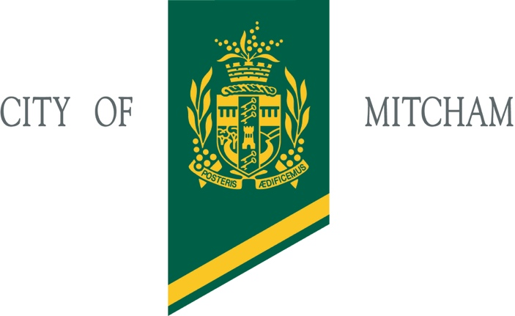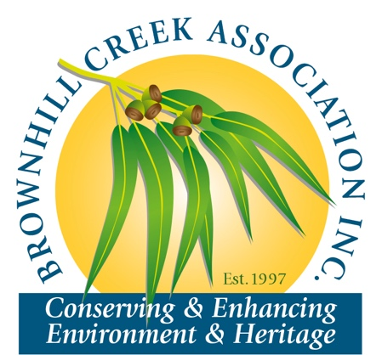

This project is proudly supported by the City of Mitcham’s Grants Program
BCA Community Engagement Officer: Ron Bellchambers (M) 0427 718 106

